25 Apr 2025

**Arriva Group submits open access rail application to connect Newcastle and Brighton, via London Gatwick**

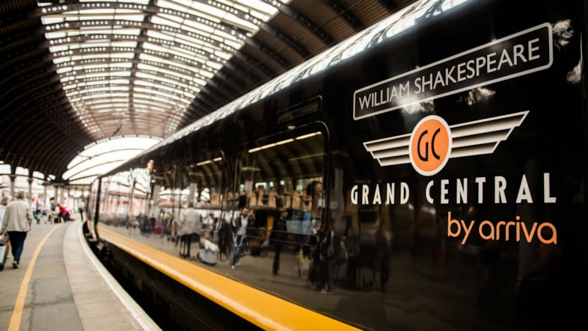

* New services operated by Arriva’s Grand Central would introduce a direct rail connection between the Northeast and Midlands to London Gatwick and the South Coast.
* Making better use of available network capacity, the proposed route would connect underserved communities in the UK and enhance long-distance connectivity without the need to interchange through London.
* The application reflects Arriva’s wider European strategy to connect people and places through sustainable transport solutions, strengthening regional economies and supporting modal shift.

Arriva Group has today announced it is submitting an open access application to the Office of Rail and Road (ORR) to introduce a new direct rail service between Newcastle and Brighton, via London Gatwick, providing vital connectivity for underserved communities along the route.

Arriva’s application, to be formally notified to Network Rail today, makes use of existing under-utilised capacity on the network and includes proposals to introduce five trains per day in each direction, along what would be the first direct route between Newcastle and Brighton.

The service would be operated by Grand Central, Arriva’s established open access rail operator, and could be introduced from December 2026. It would deliver a direct connection from the Northeast and Midlands to London Gatwick and the South Coast, removing the need to interchange through London and providing passengers with a more efficient, affordable and sustainable travel option.

The plans are part of Arriva Group’s broader commitment to strengthening regional connectivity and making better use of available rail capacity. By opening up new travel corridors, Arriva is helping to connect more people to jobs, education and leisure opportunities – and to encourage a greater shift from private cars to public transport.

**Paul Hutchings, Managing Director of Arriva UK Trains’ Rail Services, said:** “We’re committed to connecting communities and enabling more people to travel in ways that are convenient and sustainable, so we’re very pleased to be submitting this application for the first direct service between Newcastle and Brighton, opening up new travel opportunities and making better use of available network capacity – all while building on Grand Central’s proud history of connecting traditionally underserved communities.

“This is an exciting time for Grand Central’s growth story and follows the extension of our existing access rights to 2038 as well as the recent announcement of an investment of around £300 million in a new battery hybrid train fleet for our existing routes, further underlining our commitment and ambition for rail in the UK.”

If approved, the new route will provide direct access to London Gatwick for many communities in cities and towns in the northeast and the midlands, such as Northallerton, Warwick and Burton-on-Trent – offering passengers a reliable, comfortable and lower-carbon alternative to road travel while easing capacity constraints on London’s transport network. Each train will offer capacity for 300 passengers, including luggage space for airport travellers, as well as on-board catering, wi-fi and charging points.

**Jonathan Pollard, Chief Commercial Officer of London Gatwick said,** “We welcome Arriva’s exploration of a regular service between London Gatwick, the Midlands and North East, and are excited about the opportunities this proposed service could bring. London Gatwick is keen to encourage passengers to use public transport and this enhanced connectivity would support underserved areas, while strengthening and growing our catchment.

“London Gatwick already boasts an extensive network supported by strong relationships with transport providers, making the airport the best connected in the UK by public transport - this proposed addition would further enhance the seamless travel options for passengers and staff.”

Other applications currently awaiting approval from the ORR include proposals for two extra daily return services between Bradford and London and an early morning and late evening return from York to London, as well as the introduction of a direct London connection to Grimsby and Cleethorpes.

Arriva is one of Europe’s largest transport operators and the only owning group in the UK rail market with experience across every major contract model – including national rail contracts with Chiltern and CrossCountry, concessions with Arriva Rail London and open access with Grand Central.

**Notes to editors:**

The proposed Newcastle to Brighton service would call at: Newcastle, Durham, Darlington, Northallerton, York, Doncaster, Sheffield, Derby, Burton-on-Trent, Birmingham New Street, Warwick Parkway, Banbury, Oxford, Reading, Wokingham, Guildford, Redhill, London Gatwick, Haywards Heath and Brighton

**About Arriva Group:**

Arriva is a leading provider of passenger transport across Europe, employing around 34,400 people and delivering around 1.6 billion passenger journeys. With buses, trains, coaches, trams, waterbuses, bike-sharing systems, on-demand transport solutions and a rolling stock leasing company, Arriva proudly connects people and communities safely, reliably and sustainably across 11 countries, delivering these services in a better way, every day. The activities of Arriva are divided into four business units: UK Bus, UK Trains, The Netherlands and Mainland Europe. Arriva has passenger transport operations in the Czech Republic, Croatia, Hungary, Italy, the Netherlands, Poland, Slovakia, Slovenia, Spain and the United Kingdom, and also operates a rolling stock leasing company in Romania.

**Contact information**

**Arriva Group press office**[communications@arriva.co.uk](mailto:communications@arriva.co.uk)

[[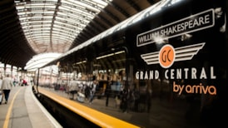](https://news.arriva.co.uk/resources/luy8g-71u09-paor1-w81nm-kdgs4)](https://news.arriva.co.uk/resources/luy8g-71u09-paor1-w81nm-kdgs4" \t "_self)

**Arriva UK Trains, Grand Central cropped-2**

[Download](https://cdn.prgloo.com/media/download/5c278675a4b24f6db66ede7eab710ace)