

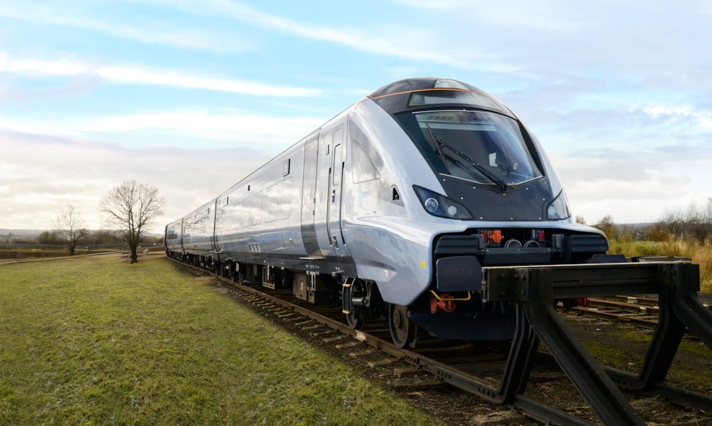
5 August 2025

Chiltern Railways secures modern trains to transform customer journeys
In a boost for regional growth, Chiltern Railways has today secured modern trains to transform customer journeys in Buckinghamshire, Oxfordshire, Warwickshire and the West Midlands.
Chiltern Railways, which is part of Arriva Group, will replace its oldest carriages (Mark 3s) with 13 modern trains (Mark 5As) which will carry customers along one of its three main routes, between London and the West Midlands, from spring 2026.
New features for customers will include plug sockets and USB ports at every seat, enhanced Wi-Fi and digital customer information screens. Customers will also benefit from onboard air conditioning, improved luggage and bike storage, and dedicated accessible areas including fully accessible toilets.
First Class carriages will also be introduced on the route in 2026, offering more spacious seats and improved connectivity for business and leisure travellers.
Chiltern has decided to fuel these newer trains with recycled vegetable oil (Hydrotreated Vegetable Oil), a renewable fuel that reduces carbon emissions and cuts pollutants such as nitrous oxide compared to conventional diesel. Chiltern has also contracted the owner of the trains to fit the latest stop-start engine technology software, helping to further reduce emissions for lineside neighbours.
Richard Allan, Managing Director of Chiltern Railways, said:
“We are thrilled for our customers that we will be able to replace our oldest trains, which are nearly 50 years old, and replace them with their modern equivalent that are just six years old and provide significant improvement to their on-board experience.
“Chiltern will be renting more trains than it has today which means we can operate additional services from the end of 2026 to help meet rising demand. The trains will be formed of modern carriages hauled by locomotives fuelled by recycled vegetable oil and fitted with the latest stop-start engine technology.
“Our 2030 vision includes a three-phase plan to modernise and decarbonise our trains. Phase one is underway with interior improvements to our existing diesel trains; phase two is to replace our oldest trains – today's announcement; we remain ambitious and determined to achieve phase three of our vision, which is to replace our 35-year-old diesel trains with battery-electric trains.”
Rail Minister, Lord Hendy, said:
“This government is putting passengers back at the heart of the 21st century railway by investing to make journeys easier, greener, and more comfortable.
“We are continuing to support Chiltern as they develop a plan to introduce additional services into their timetable, giving people more opportunities to work, live, and socialise.
“Great British Railways will unite our railway with one mission – delivering excellent services for passengers wherever they travel, and improving connectivity, driving growth, jobs, and homes as part of the government’s plan for change.”
Adam Cunliffe, CEO of Beacon Rail, said:
“Beacon is delighted to support Chiltern with the lease of the Mark 5A fleet, providing additional capacity with new trains that will enhance the passenger experience. Working closely with the Department for Transport and Chiltern, the introduction of the Mark 5As reflects the strong collaboration that Beacon provides to its customers. Beacon is engaging with Chiltern to commence services by spring 2026.”
Following a positive decision from the Department for Transport, these newer trains will enter service on a phased basis from early next year as a crucial step in delivering Chiltern’s 2030 Vision of easier, greener, and better journeys. The operator is also working with partners to confirm details of additional timetabled services which would start in December 2026.
Images link: Chiltern Railways secures modern trains to transform customer journeys | Chiltern Railways News

Notes to editors
Chiltern Railways and Beacon Rail have on August 4, 2025 signed a lease confirming the agreement for the delivery of 13 sets of Mark 5A carriages.
For more information on the new trains and customer features, visit here.
- Chiltern Railways is part of the Arriva group, one of the leading providers of passenger transport in Europe, employing around 36,200 people and delivering around 1.5 billion passenger journeys across 11 European countries.
- Chiltern operates commuter/regional rail passenger services from its Central London terminus at London Marylebone along the M40 corridor to destinations in Buckinghamshire, Oxfordshire and Warwickshire, as well as long-distance services to the West Midlands along two routes. Services on the Chiltern Main Line run from London Marylebone to Birmingham Snow Hill, Stratford-upon-Avon and Oxford, with some peak-hour services to Stourbridge Junction.
- Chiltern also runs trains on the London to Aylesbury Line to Aylesbury (with some trains terminating at Aylesbury Vale Parkway instead), on the Princes Risborough to Aylesbury and Oxford to Bicester branch lines.

