**PRESS RELEASE**

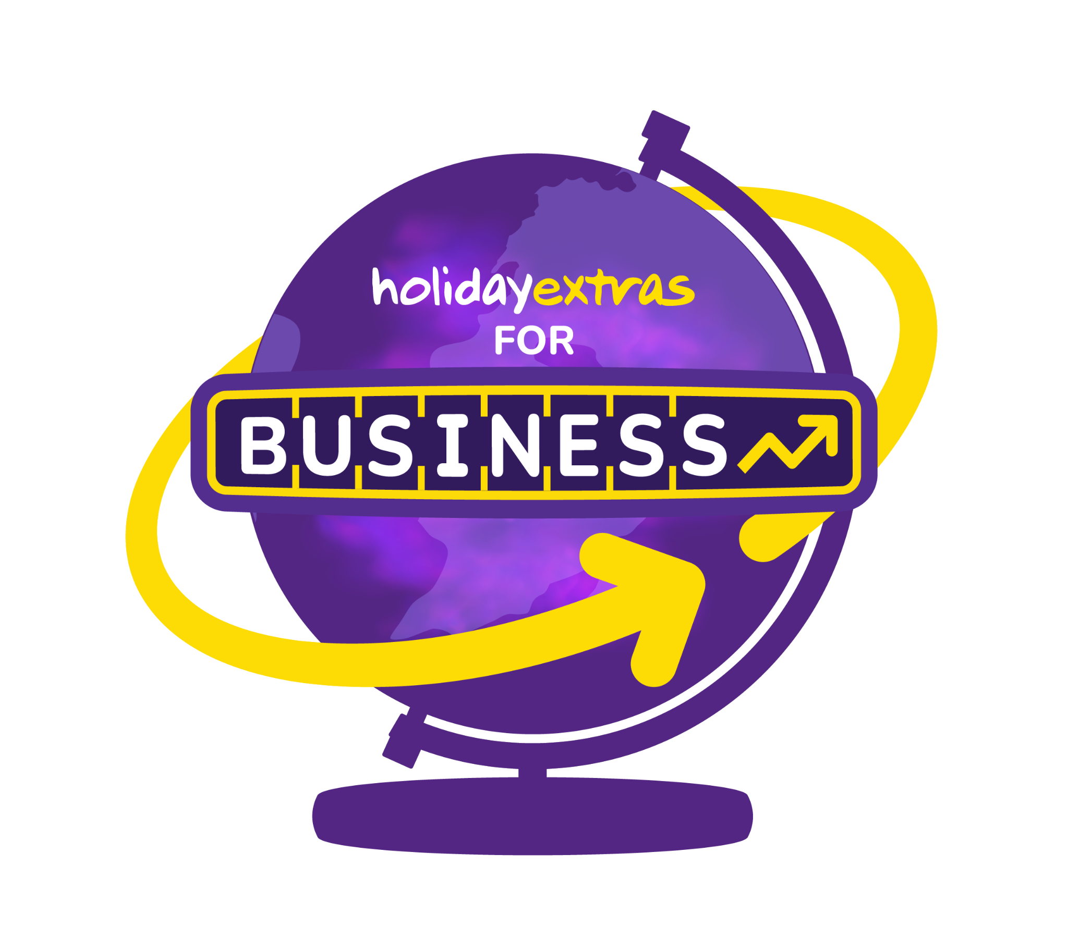

**Holiday Extras join the Business Travel Association**

**London, 03.02.2025** – The Business Travel Association (BTA) is delighted to welcome Holiday Extras as its latest partner, effective March 2025. This partnership aligns with Holiday Extras’ commitment to supporting business travel and enhancing corporate travellers’ experiences across the UK and internationally.

Holiday Extras has over 40 years' experience providing holiday extras, including airport parking, airport hotels, airport lounges, airport transfers, car hire, holiday insurance and UK breaks. Combining innovative technology with award-winning customer service, Holiday Extras' expert team helps over eleven million travellers every year with their travel needs.

**Clive Wratten**, CEO of the BTA, welcomed the partnership, saying: *"We are thrilled to partner with Holiday Extras, a leading player in the UK’s travel infrastructure. Its increased focus on supporting the business travel community complements our mission to drive excellence and innovation across the sector. Together, we’ll work to enhance the traveller experience and reinforce the vital role of business travel in the UK."*

**Kayleigh Dawkins, Partnerships Development Manager at , Holiday Extras**, said: “For more than 40 years we’ve been the UK market leader in holiday extras, and we’re proud to bring the same expertise to the business travel community. Holiday Extras helps more than 11 million people have a better trip every year, and whether you need a lounge before your flight, secure and reliable parking at the airport or a transfer that’ll get you to your meeting on time we’ve got you covered.”

**Notes to Editors:**

**About The BTA**

The BTA is the authority on business travel. Working collaboratively across the industry and with the government to promote the integral role of business travel and events to the wider economy.

Originally founded in 1967, the BTA has a diverse membership and roster of industry partners. Its TMC membership accounts for over 90% of UK expenditure on managed business travel, delivering value for money and great service to business travellers in the private, public and not-for-profit sectors. The BTA focuses on delivering practical solutions to challenges and market changes, as well as supporting best practice, sustainability and the well-being of travellers.

**About Holiday Extras**

Holiday Extras is the UK market leader in airport parking, airport hotels, worldwide airport lounges, destination car hire, airport transfers and holiday insurance. Established in 1983, Holiday Extras helps more than 11 million travellers have a better holiday every year. When booking with Holiday Extras, if plans change, no matter what the reason, Flextras ensures it will always be easy and free to cancel the booking and reschedule for another date. The company has been listed eleven times in The Sunday Times 100 Best Companies to Work For.

For more information on BTA please visit: [www.thebta.org.uk](http://www.thebta.org.uk)

For more information on Holidayextras please visit [www.holidayextras.com](http://www.holidayextras.com)

**For PR and Media Enquiries please contact Natasha Kaursland or Yoan Dzhugdanov.**

**Group Email - BTA@eulogy.co.uk**